Cloud Computing
It is providing computing services like Virtual machines, storage, databases, network, AI, ML, and IoT services over the internet. You don’t need physical infrastructure or need to manage it, all services can be used via the internet.

Shared responsibility Model in Cloud
- IaaS — allows you to rent hardware and have control over OS (VM, VNet)
- PaaS — allows you to manage applications without controlling underlying OS (DB)
- SaaS — allows subscription to a software (Office 365)
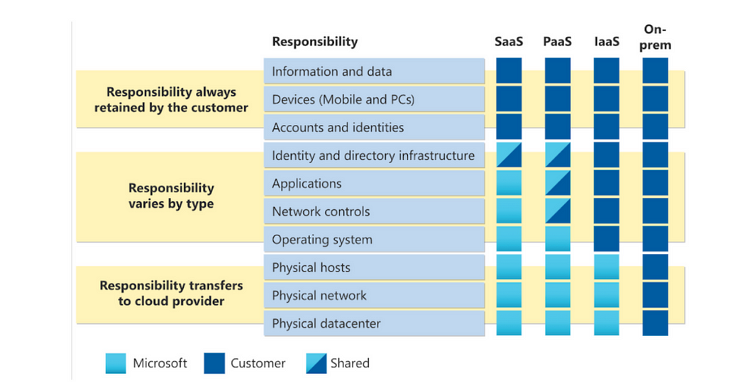

Cloud Models
- Private — Cloud that is built maintained and used by a single entity
- Public — Cloud is maintained by a third party anyone can use its services
- Hybrid — Uses both public and private cloud in an inter-connected environment. Users can choose which data to keep where
- Multi-cloud — More than 1 public cloud, some services from cloud 1, others from cloud 2, and so on..
- Azure arc — helps manage clouds (whether hybrid, private, single, or multi)
- VMware(gives VM) — easily transfer VMware from private cloud to azure

Consumption-Based Model
Cloud computing falls under OpEx (Operational Infrastructure) because cloud computing operates on a consumption-based model. With cloud computing, you don’t pay for the physical infrastructure, instead, you pay for the IT resources you use.

Describing the Benefits of cloud computing

Benefits of high availability and scalability
- Availability — Very less downtime(time for repairs and maintenance when service cannot be used), a part of SLA (Service level agreements)
- Scalability — easily adjust resources to meet demand.
Vertical — means increasing or decreasing capacity of a resource (more data storage space, increasing processing power of VM)
Horizontal — means adding or removing resources

Benefits of Reliability and Predictability
- Reliability — the cloud is decentralized so if one center goes down others are still running
- Predictability
Cost — can track resources in real-time and plan accordingly
Performance — autoscaling, load balancing, high availability

Benefits of governance and security
- Templates to ensure corporate standards
- Helps audit any resources that are out-of-standards
- Maintainance and patches are automatically taken care of
- More robust to DDOS than IaaS

Benefits of Management in the cloud
- Easy scaling
- Deploy resources based on pre-set templates
- Monitor resource health

Describing cloud Service Types

Scenarios
- IaaS
Lift-and-shift migration: You’re standing up cloud resources similar to your on-prem datacenter, and then simply moving the things running on-prem to running on the IaaS infrastructure.
Testing and development: You have established configurations for development and test environments that you need to rapidly replicate. You can stand up or shut down the different environments rapidly with an IaaS structure while maintaining complete control.
2. Paas
Development framework: PaaS provides a framework that developers can build upon to develop or customize cloud-based applications. Similar to the way you create an Excel macro, PaaS lets developers create applications using built-in software components. Cloud features such as scalability, high availability, and multi-tenant capability are included, reducing the amount of coding that developers must do.
Analytics or business intelligence: Tools provided as a service with PaaS allow organizations to analyze and mine their data, finding insights and patterns and predicting outcomes to improve forecasting, product design decisions, investment returns, and other business decisions.
3. Saas
Email and messaging.
Business productivity applications.
Finance and expense tracking.

Describing the Core Architectural components of Azure
The Azure core architecture can be broken down into 2 parts: physical infrastructure and management infrastructure
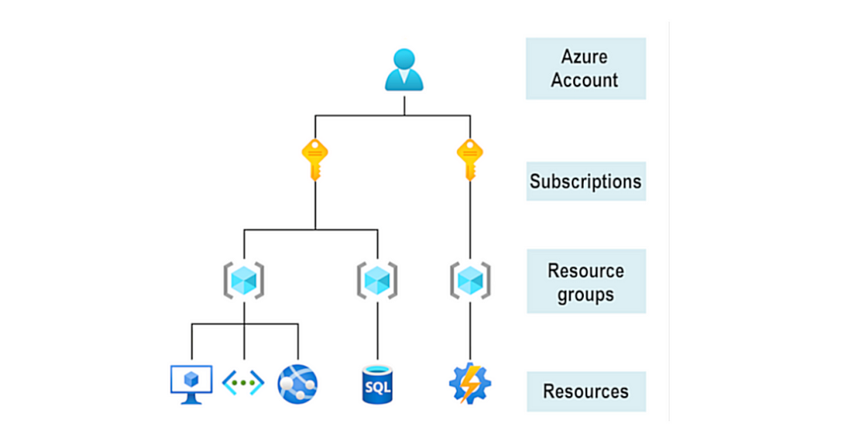

Azure Physical Infrastructure
- Regions — Contain one or many data centers that are networked together
- Availability zones — physically separate data centers within an azure region
- Region Pairs — Most Azure regions are paired with another region within the same geography (such as US, Europe, or Asia) at least 300 miles away.

Azure Management Infrastructure
- Azure Resource and Resource group
Resource is basic block — VM, virtual networks, databases, cognitive services, etc.
Resource group — Groupings of resources
- Subscriptions — are a unit of management, billing, and scale. First thing that needs to be created if you are using/ shifting to Azure
- Management groups — Azure management groups provide a level of scope above subscriptions. You organize subscriptions into containers called management groups and apply governance conditions to the management groups.

Hands-on: Creating an Azure Resource
- Sign in to the Azure portal.
- Select Create a resource > Compute > Virtual Machine > Create.
- The Create a virtual machine pane opens to the basics tab.
- Verify or enter the following values for each setting. If a setting isn’t specified, leave the default value.
- After creating a VM, we can verify that Azure created a VM along with all associated resources

Hands-on: Verify an existing resource
- Select Home
- Select Resource groups
- Select the [Resource group name] resource group

Describing Azure Compute and Networking Services

Azure Virtual Machines
- VMs provide IaaS in the form of Virtualized server. VMs can be created from pre-existing templates
- Scale VMs in Azure — VM can be single or multiple for scalability, availability, and redundancy
2.1 VM scale sets — The number of VM instances can automatically increase or decrease in response to demand, or you can set it to scale based on a defined schedule. Virtual machine scale sets also automatically deploy a load balancer to make sure that your resources are being used efficiently. They also provision VMs automatically.
2.2 VM availability sets -
Update domain — All machines in one update domain will be updated together
Fault domain — All VMs are split across different Fault domains, each fault domain has the same power source. This helps incase of a power failure.
Any service failure notification that might affect VM availability can be viewed in VM only. Can be accessed over the internet using an IP address

Azure Virtual Desktop
Azure VDI is a type of Azure VM. It is a type of desktop and application virtualization that runs on the cloud. Supports remote desktop clients on Mac and IoS. Charged for VM where AVD runs. ADV users should exist in the same AD that is linked with Azure AVD.

Azure Containers
A container bundles an app and its dependencies, then deploy it as a unit to a container host. Much like VMs, we have multiple Containers. The only difference is that while VMs virtualize hardware, Containers virtualize the operating system. Allows running multiple containers on a single host. Eg- Docker
- Accessible over internet
- Can run on Windows or Linux
- Auto Scaling
Azure Container Instances — Simplest way to run a container without any VMs (PaaS)

Azure Functions
Event-driven, serverless compute option that does not require VM or Containers. Benefits of Azure functions-
- Scale automatically on the basis of a demand
- Only charged when the function is used

Azure Application Hosting Options
Ways to host-
- VM — a way to host Apps with full control of the hosting environment
- Container — good option, as it can isolate and individually manage different aspects of hosting solutions
- Azure App Services — an HTTP-based service for hosting web applications, REST APIs, and mobile backends. It supports multiple languages, including .NET, .NET Core, Java, Ruby, Node.js, PHP, or Python. It also supports both Windows and Linux environments. Enables you to perform automated deployment from Azure DevOps. Advantages-
Deployment and management integrated into the platform
Endpoints can be secured
Load balancing and traffic manager ensure high availability
Sites can be scaled quickly to manage traffic

Azure Virtual Networking
Azure virtual networks and subnetworks enable communication between VMs, web apps, databases with each other, and users on the internet or on-premises systems. There are 2 kinds of end-points in an Azure network to enable communication between internal or external resources-
- Private endpoint — private IP address assigned to a resource within an Azure network
- Public endpoint — Public IP address is assigned to a resource and can be accessed by anyone over the internet
Highlights-
- Isolation and Segmentation — Multiple isolated networks can be created in Azure. Public or Private IP addresses can be chosen from an IP address range for a network
- Communication between Azure Resources -
VMs can connect not only to VM but any other resource
Service endpoints can connect to multiple Azure resources
3. Communicate with on-premises resources — Azure enables the creation of networks that include local and cloud resources, here are 3 ways to achieve this-
Point-to-site virtual private network connections are from a computer outside your organization back into your corporate network. In this case, the client computer initiates an encrypted VPN connection to connect to the Azure virtual network.
Site-to-site virtual private networks link your on-premises VPN device or gateway to the Azure VPN gateway in a virtual network. In effect, the devices in Azure can appear as being on the local network. The connection is encrypted and works over the internet.
Azure ExpressRoute provides dedicated private connectivity to Azure that doesn’t travel over the internet. ExpressRoute is useful for environments where you need greater bandwidth and even higher levels of security.
4. Route Network Traffic — Azure lets you control routing as:
Router Tables allow you to define rules about how traffic should be directed
Border Gateway Protocol propagates on-premises BGP to Azure networks
5. Filter Network Traffic -
Network Security Groups — to create multiple outbound and inbound security rules
Network Virtual Appliance — This is a VM that aids information flow to other devices on the network
6. Connect Virtual Networks — Peering ( the exchange of data directly between internet service providers, rather than via the internet ) is used to connect Virtual Networks which is completely private

Azure Virtual Private Networks
A virtual private network (VPN) uses an encrypted tunnel within another network.
- VPN Gateways — You can deploy only one VPN gateway in each virtual network. However, you can use one gateway to connect to multiple locations, which includes other virtual networks or on-premises datacenters. A VPN type needs to be defined -
Policy-based
Route based
2. High Availability scenarios — To ensure VPN is highly available and fault tolerant -
Active/ Standby — 2 instances are deployed, 2nd one is a substitute
Active/active — A unique IP address is assigned to each instance. Then separate tunnels are created from the on-premises devices to each IP address
ExpressRoute failover — Another high-availability option is to configure a VPN gateway as a secure failover path for ExpressRoute connections.
Zone redundant gateways

Azure ExpressRoute
Helps connect on-premises data with a cloud over a private connection. Connects don’t go over the internet.
- Features and Benefits-
Global connectivity
High reliability via built-in redundancy
Dynamic routing via border gateway protocol
2. Connectivity models
CloudExchange colocation — If your facility is co-located at a cloud exchange, you can request a virtual cross-connect to the Microsoft cloud.
Point-to-point Ethernet connection -A point-to-point connection between your facility and the Microsoft cloud
Any-to-any networks — Connect your WAN with Azure
Directly from ExpressRoute sites — Connect to Microsoft’s global network

Describe Azure DNS
Benefits-
- Reliability and Performance -
- Security
- Ease of use
- Customizable VN with private domain
- Alias records

Azure Storage Services

Azure Storage Accounts
- Standard general-purpose v2
- Premium block blobs
- Premium file shares
- Premium page blobs

Azure Storage redundancy
- Redundancy in the Primary region — Data is replicated 3 times in the primary region for which Azure offers two options
Locally redundant Storage (LRS) — Replicates data 3 times within a single data center in primary region. Lowest cost redundancy option. Offers least durability.
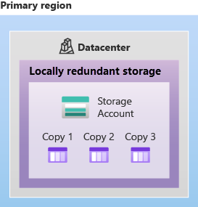
Zone redundant Storage (ZRS) — Replicates datavacross 3 different availability zone in primary region .Durable.
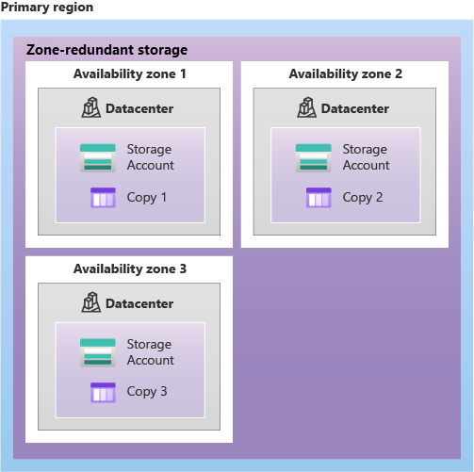
2. Redundancy in a secondary region — Data is replicated to a secondary region that is miles away from primary region. Azure offers 2 options
Geo-redundant Storage (GRS) — GRS copies data 3 times within a primary and secondary region using LRS.
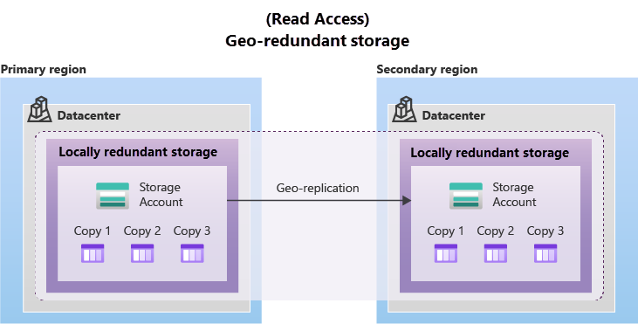
Geo-zone-redundant storage (GZRS) — Data copied in primary region using ZRS, data replicated in secondary region using LRS
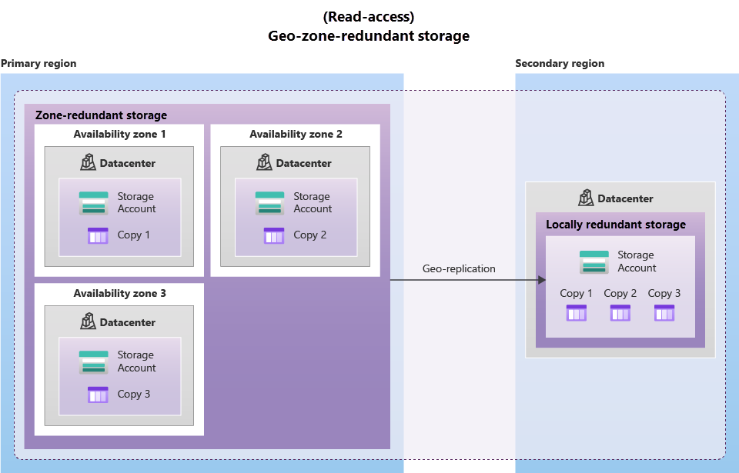
Read access to data in the secondary region — Data in the secondary region is only available to be read-only if the primary region is failed if read access is not enabled otherwise always readable

Azure Storage Services
Includes the following services -
- Azure Blob Storage — Stores unstructured data that is accessible over the internet. Blob Storage Tiers — Helps you store data in a cost effective manner
Hot access tier — For data that is accessed frequently
Cool access tier — Infrequently accessed and stored for atleast 30 days
Archive access tier — Data that is rarely accessed and stored for atleast 180 days
2 Azure Files — Fully managed file shares in the cloud that are accessible via SMB or NFS protocols
3 Queue Storage — Storing a large number of messages. Can be accessed using HTTP or HTTPS.
4. Disk Storage — Block-level storage volumes managed by Azure for use with VMs. They are a cloud version of physical disks.

Hands On: Creating a Storage Blob
Creating a storage account:
- Sign in to the Azure portal at https://portal.azure.com
- Select Create a resource.
- Under Categories, select Storage.
- Under Storage Account, select Create.
- On the Basics tab of the Create storage account blade, fill in the following information. Leave the defaults for everything else.
- Select Review + Create to review your storage account settings and allow Azure to validate the configuration.
- Once validated, select Create. Wait for the notification that the account was successfully created.
- Select Go to the resource.
Work with Blob Storage
- Under Data storage, select Containers.
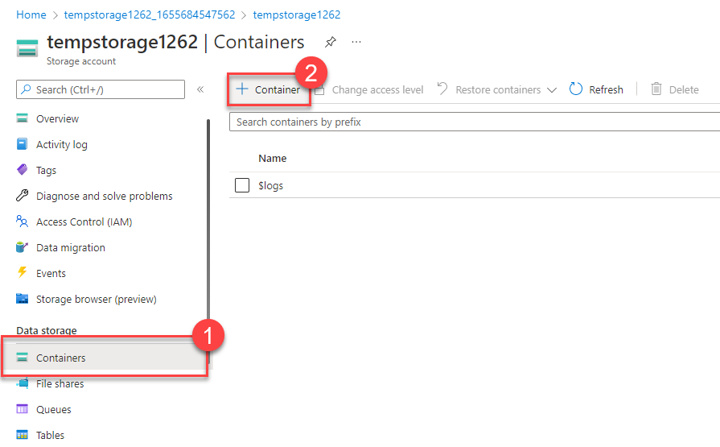
- Select + Container and complete the information.
- Select Create
- Back in the Azure portal select the container you created, then select Upload.
- Browse for the image file you want to upload. Select it and then select upload
- Select the Blob (file) you just uploaded. You should be on the properties tab.
- Copy the URL from the URL field and paste it into a new tab. You should receive an error message similar to the following. -> The specified resource does not exist.
Change Access level of your Blob
- Go back to the Azure portal
- Select Change access level
- Set the Public access level to Blob (anonymous read access for blobs only)
- Select OK
- Refresh the tab where you attempted to access the file earlier.

Azure Data Migration Options
Azure supports both real-time/ synchronous migration of infrastructure, applications, and data using Azure Migrate and asynchronous migration using Azure Data Box
- Azure Migrate — Provides:
- Unified Migration Platform
- Range of tools —
Azure Migrate: Discovery and assessment — Discover and assess on-premises servers
Azure Migrate: Server Migration — Migrate to Azure
Data Migration Assisstant — assesses SQL servers
Azure database migration Service — Migrate on premises databases to SQL
Web app migration assisstant — asess on-premises websites for Migration to Azure App Service
Azure DataBox — To move large amounts of offline data to Azure. Physical migration service. Larger than 40TbB data. No to limited network connectivity.
4. Assessment and Migration

Azure File movement Options
- AzCopy — To share blobs or files (including synchronous files) to or from storage account/ cloud providers
- Azure Storage Explorer — Provides a graphical interface to manage files and blobs in Azure Storage Account
- Azure file Sync — Lets you centralize your file shares. Bi-directionally syncing files in Azure and local systems

Azure Identity, access and Security

Azure Directory Services
Azure AD is a directory service that enables you to sign in and access both Microsoft cloud apps and cloud app that you develop. Also help you maintain on-premises Active Directory deployment. It is used to retrieve security tokens.
Types of AD-
- Free
- Office 365
- Premium P1 — RBAC & Conditional access
- Premium P2 — Identity protection, Self-service entitlement management and privileged Identity management

Azure Authentication Methods
- Microsoft Authenticator app — Multi-factor authentication from phone
- FIDO2 security keys — third party key

Azure external Identities
Identifies all the ways that you can securely interact with users outside organization. The following capabilities make up External identities:
- B2B collaboaration
- B2B direct connect
- Azure AD buisiness to customer (B2C)

Azure Conditional access
Used by Azure AD to allow or deny access to a resource based on identity signals

Azure role-based access control
Azure assigns roles (built in or custom) to users so that they are only granted the information they should. Each roles has a set of permissions assosiated with it.

Zero Trust Model
Model that assumes worst case scenario and protects resources with that expectation.

Defense — in-depth
To protect information and prevent it from being stolen by those who are not authorized to access it. Layers of defense-in-depth-
- Physical Security — Securing access to buildings
- Identity and access — Identities are secure and access is granted only to what is needed
- Perimeter — The network perimeter protects from network based attacks against your resouces. DDoS protection. Firewall
- Network — Limit communication between resouces to limit impact of an attack
- Compute — Makes sure that compute resources are secure
- Application — Ensure that apps are secure, Store sensitive app info in a secret storage. Make security a design requirement for all applications
- Data — Secure data properly
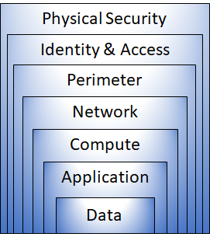

Microsoft Defender for Cloud
Monitoring tool for security management and threat protection. Protection across all types of cloud infrastructures. On the Regulatory compliance dashboard of MDFC you can find the overall compliance and score and the number of passing and failing assessments
- Access — Defender for cloud helps you continuously assess your environment.
- Secure -
Overall security score can be found in secure score section of MDFC
3. Defend -
Security alerts — Security alters ranked by severity are a part of security alert
Advanced threat protection

Cost Management in Azure

Factors that affect cost
Only required an Enterprise Agreement to use Azure Cost Management
- Resource Type
- Consumption
- Maintainance
- Geography
- Network Traffic
- Subscription Type
- Azure Marketplace

Pricing and Total Cost of Ownership calculators
- Pricing Calculator — Cost for provisioning resources in Azure
- TCO Calculator — compares costs running on-premises infrastructure vs Azure cloud (define server, storage, and networking to compare costs)

Hands-on: Using a Pricing Calculator
Use the Pricing calculator and fill in fields

Hands-On: Using a TCO Calculator
use the Total Cost of Ownership (TCO) Calculator to compare the cost of running a sample workload in your datacenter versus on Azure.

Azure Cost Management tool
Tool to quickly check Azure resource costs, create alerts based on resource spending, and create budgets. Cost analysis, a subset of Cost Management provides a visual for your Azure costs.
- Cost Alerts -
Budget alerts
Credit alerts
Department spending quota alerts
2. Budgets

Tags
Resource tags are a way to organize resources. Tags provide extra information, or metadata, about your resources.

Features and tools in Azure for Governance and Compliance

Azure Blueprints
Used to define repeatable settings, for the rapid scaling of resources. Azure Blueprints lets you standardise cloud subscription or environment deployments. Instead of having to configure features like Azure Policy for each new subscription, with Azure Blueprints, you can define repeatable settings and policies that are applied as new subscriptions are created
Artifact — Each component in Blueprint is known as an artifact

Azure Policy
Azure Policy is a service in Azure that enables you to create, assign, and manage policies that control or audit your resources. Allow you to specify what type of resource can be created
Azure Policy enables you to define both individual policies and groups of related policies, known as initiatives

Resource Locks
Prevent resources from being accidentally changed or deleted. It is applied to all users and roles.

Exercise — Configure a resource lock
Apply a read-only resource lock
- Scroll down until you find the Settings section of the blade on the left of the screen.
- Select Locks.
- Select + Add.
4. Enter a Lock name.
5. Verify the Lock type is set to Read-only
6. Select OK.

Service Trust Portal
The Microsoft Service Trust Portal is a portal that provides access to various content, tools, and other resources about Microsoft security, privacy, and compliance practices.

Describing features and tools for managing and deploying Azure resources

Tools for Interacting with Azure
- Azure Portal — The Azure portal is a web-based, unified console that provides an alternative to command-line tools. With the Azure portal, you can manage your Azure subscription by using a graphical user interface.
- Azure Cloud shell — Azure Cloud Shell is a browser-based shell tool that allows you to create, configure, and manage Azure resources using a shell.
Azure Powershell — uses Power Shell commands
Azure CLI — uses bash commands

Azure Arc
Tool to monitor hybrid and multi-cloud environments

Azure Resource Manager and ARM templates
Deployment and Management Service for Azure. ARM authorizes requests sent by a user. It provides a management layer that enables you to create, update, and delete resources in your Azure account. Templates use JSON syntax
ARM Template -
Declarative Syntax
Repeatable results
Orchestration — Takes care of deployment, whether in a specific order or in parallel
Modular files — Re-use parts of templates
Extensibility -

Monitoring tools in Azure

Purpose of Azure Advisor
Evaluates Azure resources and makes recommendations to help improve reliability, security and performance, achieve operational excellence and reduce costs. the Advisor dashboard displays personalized recommendations for all your subscriptions.

Azure Service Health
Service Health provides a narrower view of Azure services and regions. It focuses on the Azure services and regions you’re using. This is the best place to look for service-impacting communications about outages, planned maintenance activities, when App Service usage exceeds quota(health advisory) and other health advisories because the authenticated Service Health experience knows which services and resources you currently use. You can even set up Service Health alerts to notify you when service issues, planned maintenance, or other changes may affect the Azure services and regions you use. Service health allows implementation of a webhook on your website to display health incidents.
- Azure Status — Inform about service outages in Azure
- Service Health — Health of services and regions you are using
- Resource health — View of your actual cloud resource

Azure Monitor
- Azure Monitor — Platform for collecting data on your resource, analyzing that data, visualizing info, acting on results.
Azure Log Analytics — Tool in the Azure portal where you’ll write and run log queries on the data gathered by Azure Monitor.
Azure Monitor Alerts — an automated way to stay informed when Azure Monitor detects a threshold being crossed. You set the alert conditions, and the notification actions, and then Azure Monitor Alerts notify when an alert is triggered.
Application Insights — monitors your web applications. Application Insights is capable of monitoring applications that are running in Azure, on-premises, or a different cloud environment

